Email/SMS Spam Classifier on supervised learning
Satendra Kumar, Shubham Sharma, Shubham, Shivani, Harshita Nailwal, Tabish Absar
Department of Computer Science and Engineering,
Moradabad Institute of Technology
Moradabad, Uttar Pradesh, INDIA
satendra04cs41@gmail.com,shubham4in@gmail.com,shubhamsingh.rsd@gmail.com,shivanisinghdilari@gmail.com, harshitanailwal28@gmail.com,Tabishabsar52@gmail.com

Abstract: - Email, which is widely accessible, typically quick to send messages, and cost-free, is one of the most prominent and frequently utilised communication strategies. Email-based hazards have increased as a direct result of the weaknesses in email procedures and growing percentage of automated commercial and commercial trades. One of the challenging problems with the modern Internet is email spam, which annoys individual customers and causes financial havoc for businesses. Without the customers' permission, spam communications target them and clog their mailboxes. When checking and removing spam emails, they use up more time and organisation resources. Despite the fact that a large majority of Web users publicly dislike spam, sufficient of them nevertheless answer to profitable deals for spam to remain a real issue. Although the majority of Web users are clear about their hatred of spam, the fact that enough of them still click on commercial offers means that spammers may still make money from it. While most customers are aware of what they should be doing, they need clear instructions on how to avoid and delete spam. Whatever steps are made to eradicate spam, they are in no way successful. Filtering is the most straightforward and practical technique among the strategies developed to stop spam. The more recent classifier-related challenges have been the focus of many studies in spam separation. Machine learning for spam detection is a crucial area of research in modern times. Nowadays, spam detection using machine learning is a crucial area for inquiry. The appropriateness of the suggested effort is examined, and it recognises the application of several learning estimations for extracting spam mails from email. Similar to this, a close review of the estimates has been provided.

Keywords: – Machine Learning, MLP, Naive Bayesian, Spam Classification,.

1 INTRODUCTION
The usage of the internet has been steadily growing ended the previous ten years and is still rising. We might therefore conclude that the Internet is progressively suitable a necessary component of daily life. Email has evolved into a helpful tool for data transfer and web use is expected to continue growing. A rare of the many benefits that email likes over other physical systems are a slight interval delay through conduction, safety of the information being transported, and inexpensive costs. However, there aren't many problems that prevent messages from being used effectively. One of them is spam email [1]. Unsolicited Bulk Email (UBE), sometimes known as spam email, has recently become a major problem online. Due to how inexpensive it is to send spam email, it is recklessly sent to a big amount of recipients. Additionally, it is crucial to takings some period to separate spam from non-spam email when a big volume of spam is expected because the mail server may fall down if the latter is not done. Several attempts have been made to recognise in order to address the spam problem. Numerous machine learning techniques have been used in previous research to address the problem, including Naive Bayes, Support Vector Machine (SVM), and many more Bayesian classifiers [2]. With the aim of being widely used to a few separating programming's, Bayesian classifiers in these approaches achieved excellent outcomes by many examiners. Nearly all techniques identify and distinguish between the list of capabilities seen in spam and non-spam messages. Spam email comes in various forms today, including advertisements with the intention of making money or selling goods, urban legends that spread hoaxes or urban legends, and so on.

2 LITERATURE SURVEY

Spam mail, commonly referred to as junk mail or UBE, is sent to a group of recipients without their consent. Spontaneous communications that arise organically from a client's mail stream are to be managed by spam filtering. These impulsive sends have historically resulted in a variety of concerns, including overflowing letter boxes, wasting business data transmission, requiring clients to invest time in sorting through it, and the vast spectrum of different issues associated to spam [3]. In 2001, there were 10,847 spams as opposed to 1753 spams in 2000, per a series of reviews put together by CAUBE. Every few years, according to AU 1, the total quantity of spam that 41 email addresses have received has climbed by a factor of six. [4].
Puniskis [5] used the brain network approach to deal with the characterization of spam in his investigation. Instead of relying on the message's unique context or keyword repetition, his method makes use of ascribes that are based on the graphic elements of the shady examples used by spammers. The data used is a corpus of 1812 spam messages and 2788 real communications that were collected over a period of time. That is how the results demonstrate that while ANN is fantastic, it shouldn't be used by itself as a spam filter.
In [6], Four distinct classifiers—Brain Organisation, SVM Classifier, Guileless Bayesian Classifier—were used to organise email data.
On the basis of various information sizes and varied element sizes, the analysis was conducted. In the event that the final grouping is spam, the final grouping result should be "1," else, it should be "0."

This study demonstrates the viability of a simple classifier that creates a binary tree on a dataset that may be referred to as tree such as binary tree.

3 DATASET DESCRIPTION

The dataset which is used here has been purchased from the Kaggle website. Five or so characteristics of the spams present in emails/sms has been found and incorporated in the dataset. Among the attributes used were the addresses that the spam came from, the sort of spam that was sent, and the organisation that sent the spam.

Kaggle offers data sets that can be used for machine learning algorithms. Data from 5527 email messages make up the spam dataset obtained from Kaggle. There are 5 attributes per instance in the Spam dataset. In the majority of the belongings, the occurrence of a specific term or character in the email that resembles to the example is shown. When comparing the distributions of the SPAM and HAM classes, it becomes clear that the data sets are unbalanced and that the SPAM class is the rare class. A fresh stable exercise data set has its data preprocessed in instruction to prevent biassing for the main class, the HAM class. It has a lot of variables, yet some of the dataset's columns are not necessary. Eliminate any unnecessary columns by doing so. The column names require an update. In order to avoid this, stop words must be removed at the preprocessing stage. Tokenization is the procedure of flouting a string of characters into words, numbers, punctuation, and other symbols, and then identifying tokens that do not need to be deconstructed in further processing, such as punctuation marks, are discarded in the tokenization process.

4 METHODOLOGY
A Data cleaning

Accurate, wrong, duplicate, and incomplete data are removed from the dataset through the process of "data cleaning." This type of information is often not useful for data analysis because it could produce erroneous results.

Finding strategies to increase data set consistency without erasing critical information is what is meant by "data cleaning," which is different from "information erasure to make room for new information." Generally speaking, data cleaning removes erroneous data and improves the data's quality.

Numerous methods can be used to clean data, and the methods used will vary based on the type of data being cleaned. We can perform the following operations to clean the data:

- Remove duplicate or pointless observations,
- correct structural issues,
- filter undesirable outliers,
- handle missing data,
- validate
- quality-assure observations.
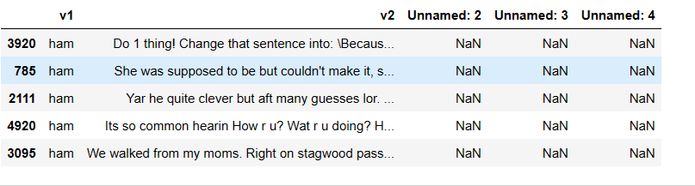

Fig. 3.1
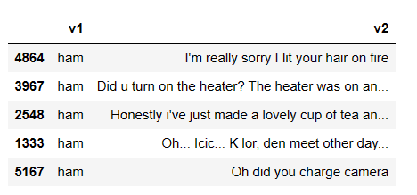

Fig.3.2

B EDA (Exploratory Data Analysis)

EDA, which commonly makes use of visual approaches, is a method for examining datasets in order to pinpoint and describe their main properties. EDA is used to looking at what the data have to say before starting a modelling job. It takes a thorough comprehension of each column in the spreadsheet or number to identify the important elements in the data.

EDA can be used to comprehend the structure of the data, identify patterns that distinguish spam from ham messages, and cover any underlying trends or features that can be applied to further in-depth research or modelling when it comes to spam and ham communications.

B.1 Pie chart

Pie Chart: Spam and Ham Messages

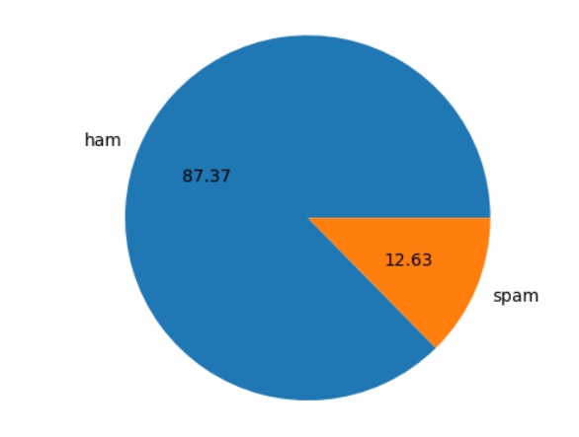
Fig. 4.1

The amount of emails falling into the ham (non-spam) and spam categories is depicted in the pie chart above.

Spam Messages (12.63%):

According to the graph, 12.63% of the messages are considered spam. Spam is a term used to describe unsolicited or unwelcome messages that are frequently delivered for commercial, malicious software distribution, phishing, or other purposes. They may annoy recipients and maybe pose a risk of damage.

Ham Messages (87.37%):

According to the graph, 30% of the communications are considered to be "ham," which denotes that they are genuine, non-spam letters. Ham communications are often those that the recipients want to receive and are relevant to them, such as emails from friends or family members, information about their jobs, or messages from reliable sources.

B.2 Historical Graph

The use of colours can be a useful visual aid to help differentiate among the two sorts of communications inside a historical graph showing spam and ham transmissions.

Red for Spam Messages: Spam messages are frequently unsolicited and unwelcome communications delivered in large numbers for commercial, phishing, or other malevolent purposes. As a result, using the colour red to represent spam communications in a historical graph might help visually express the concept that these messages are unwanted and possibly hazardous.

Blue for Ham Messages: Contrarily, ham transmissions are lawful communications that are not categorised as spam. They can be emails from well-known contacts, subscription-based newsletters, or additional messages that the receiver has requested and expected. Consequently, using the colour blue to denote ham signals in a historical graph.

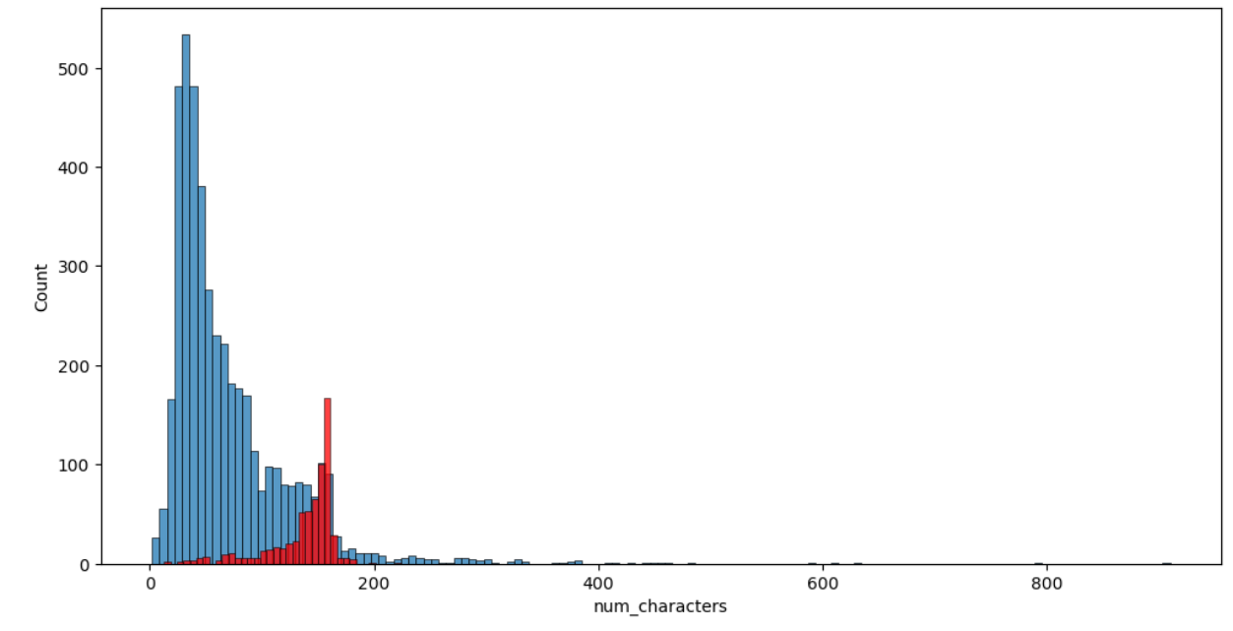
Fig. 4.2 historical graph for num_characters

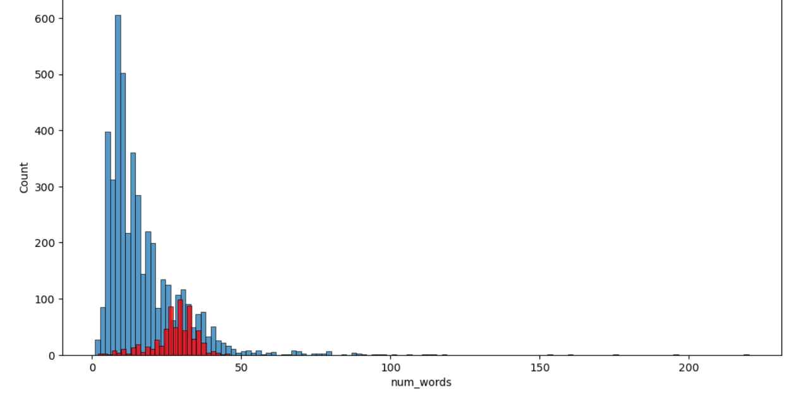
Fig.4.3 historical graph for num_words

You can distinguish between spam and ham communications in a history graph by using different colours to represent the two sorts of messages..

B.3 Pair Plot

A sort of scattering matrix called a pair plot shows scatter plots of various variables in a grid-like arrangement. Each grid cell shows a scatter plot of a pair of variables combined, usually with the same axes.

In a pair plot graph, you can utilise two different markers or colours to distinguish between ham and spam messages. For instance, you could use different colours (like using blue for ham and red for spam) to distinguish between the two groups, or you could use blue for ham and red for spam.

The correlation between two variables or attributes taken from the messages would be depicted by each scatter plot in the pair plot graph. These factors could include details like message length, the existence of specific words or phrases, the presence of particular letters or symbols, or any other pertinent details which can help classify communications as ham or spam.
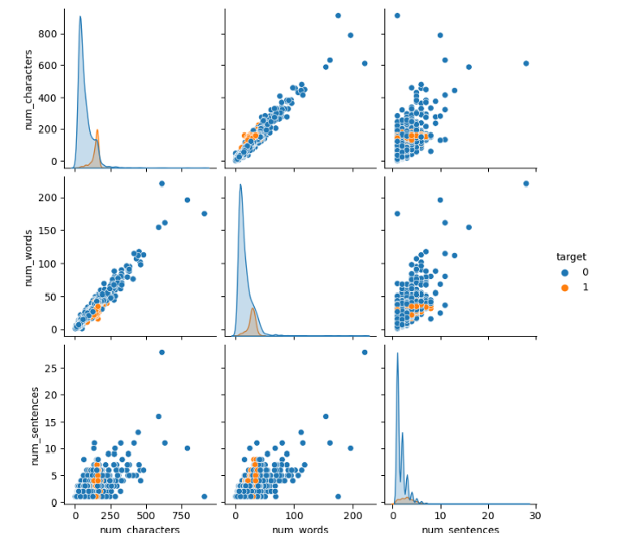

Fig 4.4: Pair plot

C Data Preprocessing

To convert unstructured text input into a form that machine learning algorithms can understand, data preprocessing is a crucial step in natural language processing. The following steps comprise the majority of data preparation:

Lower case: For the sake of maintaining uniformity throughout the data, we transform all the text to lower case in this stage.

Tokenization: The next step is to tokenize the text data, which requires breaking the text down into individual words or tokens. This stage facilitates the examination of the textual material.

Removing special characters: Punctuation marks, symbols, and other non-alphabetic characters are examples of special characters that can amplify the noise in the data and make analysis more challenging. To avoid confusion, we eliminate any special characters from the text data.

Removing stop words and punctuation: Stop words, such as "the," "and," "a," etc., are frequent words that don't offer much value to the text data. We eliminate all stop words from the text data in this stage. Punctuation is likewise eliminated because it serves no purpose in text analysis.

Stemming: In order to decrease the number of unique terms in the text data, in this stage, we transform words into their root form. By doing so, the vocabulary can be condensed and the data analysis process is facilitated.

By using these data pretreatment techniques on the unstructured text data, we can convert the unstructured text data into a format that machine learning algorithms can analyse.

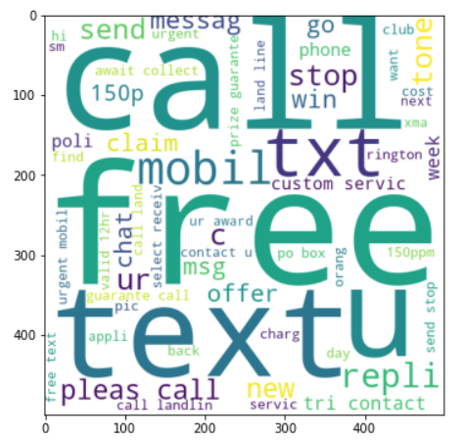
Fig.4.5: Spam Word Cloud
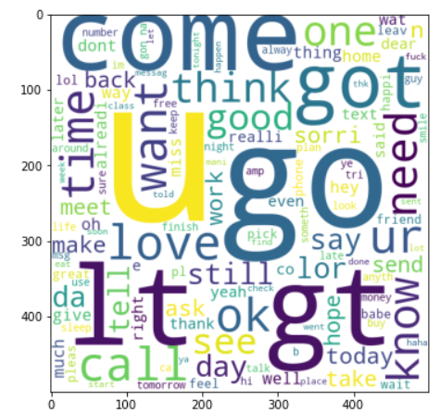
Fig.4.6: Ham Word Cloud

D Model Building
These supervised learning methods were put into place after a dataset analysis to decide which performance would be better [7]. Different representations of the knowledge are generalised by using a variety of techniques and biases. As a result, there is a propensity for this to display an error on various regions of the instance space.The hypothesis that uses multiple algorithms together might be more successful in correcting errors that are unrelated.
Classifier fusion and classifier selection are two paradigms that may be used to govern the ensemble types of various classification algorithms. A single algorithm is selected from the available classifier options in this case to categorise the examples (new instances), and another combines the algorithmic choices. We highlight the most crucial techniques from both categories in this section. One method of decision-making is classified selection.
The best classification algorithms are chosen for use on the test set after this approach evaluates the algorithms on the training set.

The fusion approach has the capacity to incorporate several kinds of classifiers as input and learn from the data.

E Classification Algorithms

To screen spam emails, classification techniques are utilised. It has keywords, phase and characteristics based studies. For filtering spam emails machine learning techniques have been used. Using the data set models build for classification algorithms. In the dataset taken from the UCI repository, there are 1813 spam emails and 2788 valid emails that were sent over the course of several months. Models for classification methods are constructed using this dataset as the training dataset.

- Support Vector Machine
- Naive Bayesian classifier
- Adaboost classifier
- GradientBoosting classifier
- Logistic regression classifier
- KNeighbours classifier
- Bagging classifier
- XGB classifier
- ExtraTrees classifier
- Random Forest classifier
- Decision Tree classifier

E.1 Naïve Bayesian classifier

The Naive Bayes Classifier, which assists in developing machine learning models that can rapidly predict outcomes, is the most simple and effective classification algorithm. The Bayes theorem serves as the establishment for the supervised learning approach used by the Nave Bayes algorithm to solve classification problems.

For the reason that it usages a probablistic classifier, it bases its predictions on the likelihood that a assumed occasion will take place. To determine the possibility of a theory assumed certain earlier info, the Bayes theorem—also known as Bayes' Rule or Bayes' law—is utilised. This can be determined via the conditional probability. The following is the formula for the Bayes theorem:

P(A|B) = P(B|A) * P(A) / P(B)

The posterior probability is P(A|B): Probability of hypothesis A with respect to the observed occurrence B.

P(B|A) is likelihood probability: Probability of the hypothesis B with respect to the observed occurrence

Priority probability, often known as P(A): likelihood theory.

P(B) is Marginal Probability: Probability of Evidence.

The Naive Bayes is a collection of three algorithms:

* MultinomialNB

* BernoulliNB

* GaussianNB

E.1.1 Gaussian Naive Bayes classifier

When deal with the constant data, it is common to make the assumption that the constant values related to every class are circulated according to a usual (or Gaussian) circulation. When working with continuous data, it's common to make the assumption that the constant standards connected to every class are dispersed according to a usual (or Gaussian) circulation. The traits' probability of occurrence is predicated on

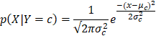
It is common to suppose that variance-
- is independent of Y (i.e., i)
- independent of Xi (i.e., k)
- or both (i.e., σ).

The Gaussian Naive Bayes model allows continuous valued structures and assumes that altogether of them follow a Gaussian (normal) circulation.

Assuming that the data is distributed in accordance with a Gaussian distribution with no covariance (independent dimensions) between dimensions is one method for developing an understandable model. This model can be fitted by calculating the nasty and normal deviancy of every point's value within each label, which is all that is necessary to create such a distribution.

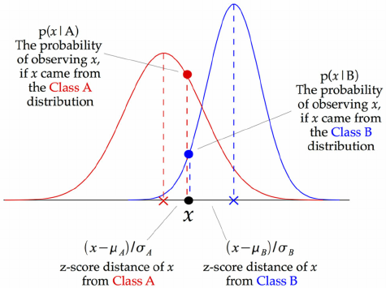

Fig. 4.7
The above image serves as an example of the Gaussian Naive Bayes (GNB) classifier. The z-score, which is the distance from the class mean divided by the class standard deviation, is calculated for each data point.

As a result, we can observe that the Gaussian Naive Bayes is effective and has a somewhat different methodology.

E.1.2 Multinomial Naïve Bayes classifier

The Multinomial Naive Bayes method is a popular Bayesian learning technique in Natural Language Processing (NLP). The programme produces an educated guess regarding a writing's label, such as that of an email or news item, via the Bayes principle. It computes the probabilities of every label for a specific example and outputs the label with the peak probabilities.

Multinomial Naive Bayes is a variation of the Naive Bayes method that is used in machine learning, and it is a great choice for use with datasets that are spread among several nodes. When there are several classes into which the text can be categorised, this approach can be used to predict the label of the text. This is accomplished by figuring out the likelihood of each label for the input text, and then producing the label with the highest likelihood as an output.

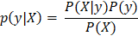

E.1.3 Bernoulli -NB classifier

IT is one of its variations. As shown by the Nave Bayes classification algorithm for machine learning, which provides the probability of an event occurring. Because it is a probabilistic classifier, the NB classifier forecasts the likelihood that input will be classified into all classes given the supplied data. It is also known as conditional probability.

Bernoulli Naive Bayes is a member of the Naive Bayes family. Only binary input is permitted. When determining if a value matches a word that appears in the document, this is the instance. That model is quite basic. When assessing word frequency is not the main factor, Bernoulli might yield more precise results. For example, whether a word appears in a document or not, each value that indicates a binary term occurrence feature must be counted. These attributes are used in place of counting the amount of intervals a term looks in the document.

Let p represent success probability and q represent failure probability as we work with binary values; q=1-p. With regard to a random variable 'X' with a Bernoulli distribution,

The Bernoulli distribution,

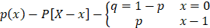

E.2 Adaboost classifier

Adaptive boosting, often known as AdaBoost, is a machine learning technique used for data collection. The most well-known calculation utilised with AdaBoost is one-level decision trees or decision trees with only one split. Additionally called "Decision stumps," these trees.

This algorithm creates a model and assigns equal weights to each data point by creating a fictitious model. Then, it assigns higher weights to incorrectly designated points. Currently, any point with a larger load is given more weight in the model that follows. Model preparation will continue until a lower error is evaluated, at which point it will stop.
Algorithm:

1. Give every data point in the dataset an equal weight when initialising the dataset.
2. Enter this as model input and find the data points that were misclassified.
3. Increase the significance of the data items that were misclassified..
4. If (received the necessary findings) move to step 5, otherwise go to step 2.
5. End.

AdaBoost is use to integrate weak base beginners, but it has too been shown to integrate powerful base beginners, alike bottomless decision trees, successfully, producing an even more accurate model.

E.3 Gradient Boosting classifier

Gradient Boosting classifier is a ML Algorithm that coming feeble models together and then generate a solid analytical models. Gradient boosting are becoming prevalent because of the their efficiency of classifying complex datasets and also applied on several kaggle datasets to the strength of the models.

Gradient Boosting Algorithm is used to build models
and try to reduce the error of the previous model.

An approach similar to gradient descent that reduces the loss function by computing the calculated loss and applying gradient descent to the loss function in order to minimise the error between parameters.

E.4 Logistic Regression classifier

Logistic regression is a grouping method use in machine learning. In order to model the reliant variable, a logistic task is use. Here only binary possible categories for the reliant variable because it is dicotomous (for example, the cancer could be malignant or not), leaving no other options. Therefore, while working with binary data, this method is used. There are only two feasible classes because of the dichotomous character of the dependent variable.

The reliant variable is, to place it simple, a binary variable, with data noted as any 1 (which show success/yes) or 0 (which show failure/no).

A logistic regression model predicts P(Y=1) as a function of X mathematically. One of the most straightforward ML methods, it might be applied to a many of classification problems, including spam detection, diabetes estimation, cancer analysis, etc.

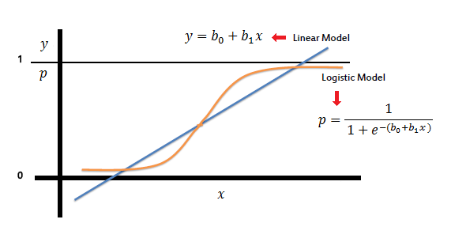
Fig.4.8

E.5 KNeighbors classifier

The most popular algorithm based on the supervised technique is the KNeighbors classifier. It assesses how similar the new case data is to the current case dataset and incorporates it into the current case data in associated categories. Using the available similarity dataset, KNN-stores the existing data and categorises a new data point.

It can be as the Regression as well as classification. KNN algorithm does not absorb by the training dataset instead, it provides the dataset and information on the classification phase. It makes a change to the dataset so, it can be also called Lazy algorithm.

E.6 SVM classifier

Support Vector Machine, or SVM, is the very popular supervised learning method, and this is use to point classification or regression difficulty. This is use in machine learning, nevertheless, to address classification difficulty.

The aim of this approach is to build the most suitable limit or line of decision that can create classes in n-dimension space, allowing us to fastly graph subsequent data facts in the relevant category. This ideal decision margin is known as the hyperplane.

The vector chosen by SVM are used to construct the hyperplane. These extreme occurrences are known as support vectors, which is why this method is called a machine using support vectors.
SVM is available in two forms:

A dataset is considered to have been linearly separated when it can be split into two groups along a straight line. A linear SVM classifier is then used to classify the dataset.

For un-linear divided data, un-linear SVM is utilised. A dataset is called un-linear when it is unable to be classified using a plane that is straight, in which case the nonlinear SVM classifier is employed to do it.

In n-dimensional space, there may be several different decision borders that can be used to separate classes, then we necessity identify the optimum choice margin that can accurately classify the data tally. The name for this ideal boundary is the hyperplane.

The dimensions of the hyperplane are determined by the features in the dataset; hence, even though there are two characteristics, the hyperplane is a straight line. Where there are three features, the hyperplane will also be a 2-D plane. We consistently create a hyperplane with maximum margin, or the widest gap among the data points.

Support vectors are a set of points or vectors that are closest to their respective hyperplane and have an effect on the position of the hyperplane.

E.7 XGBoost classifier

XGBoost is the execution of the gradient boosted decision trees which is being planned for speediness and performance that is good machine learning.

A decision tree-based machine learning approach called Extreme Gradient Boosting, or XGBoost, employs boosting to improve performance. It has been one of the most effective machine learning algorithms since it was first developed, routinely outperforming other algorithms.

Although XGBoost also offers libraries for Python and integrates nicely with scikit-learn, scikit-learn is a machine learning platform that Python data scientists typically use. It may be used to address classification and regression problems and is ideal for a broad range of data science applications.

E.8 Extra Trees classifier

Extremely Randomised Trees Classifiers, often referred to as Extra Trees Classifiers, are an ensemble learning method that combines the output of several decorrelated decision trees gathered in a "forest" to produce classification results. The way the decision trees within the forest are constructed is the only way that it is distinct from the Random Forest Classifier.

Every single decision tree in an Extra Trees Forest is built using the original data used for training. The most suitable feature to split the information at each node must then be selected by each decision tree from a randomly selected group of k features drawn from a feature collection. This random sample of features results in a large number of de-correlated decision trees.

To execute the feature selection using the aforementioned forest structure, the standardised overall reductions in the mathematical criteria used in the split decision feature is computed. Gini This value is called the feature's importance.

E.9 Random Forest classifier

The supervised learning approach includes the machine learning algorithm Random Forest. Machine learning uses it for both regression and classification problems. It is based on the concept that ensemble learning, which is the process of combining several classifiers to address complex problems and improve model performance.

Considering what the name implies, "Random Forest is a classifier in which the number of decision trees on various subsets of the dataset and takes average to improve the predictive accuracy of dataset." Instead of using a single decision tree, the random forest makes use of prediction from each tree and predicts the outcome based on which predictions garnered the most overall votes.

A majority trees there are in the forest, the more accurate it is and less overfitting occurs.

The method known as Random Forest should be utilised for the following reasons:
- Compared to other systems, it takes less time to train users.
- It is capable of making exact predictions regarding the outcome regardless of a larger dataset.
- Even when a sizable quantity of data is missing, it can still be correct.

E.10 Decision Tree classifier

An example of supervised learning is the Decision Tree Classifier. The decision tree classifier functions similarly to a typical tree with roots, branches, and leaves. Attributes are tested on each internal node, the results are displayed on the tree's branches, and the leaf node receives the results.

A decision Tree is a type of tree where each node represents a feature, each branch a choice, and each leaf an outcome. If, as its name suggests, a root node is the uppermost node, it is the parent node. The entire concept is aided by the creation of a tree for all of the data, which is then processed at each leaf node.

A decision tree refers to a tree-based approach in which the beginning of the tree is characterised by a data separation sequence or the shape of the tree's root up until a boolean outcome at the leaf node of the tree.

Divide and conquer tactics are used in decision tree learning to find the ideal split points within the dataset by using a greedy search approach.

We employ the CART technique, which stands for Classification and Regression Tree algorithm, to visually display all potential solutions based on the criteria. In a decision tree, the question is simply posed, the response is (Yes/NO), and the tree is then divided into subtrees.

E.11 Bagging classifier

A bagging classification is a group of meta-estimators that combine their separate forecasts to produce a final prediction after each meta-estimator fits a base classifier independently to a set of randomised subsets of the initial dataset. The black-box estimate as a decision tree can be made more accurate by introducing randomness to its development mechanism and then making a collection from it, a meta-estimator of this kind is frequently used as a technique for reducing the disparity between estimates.

A preparation set is used to build each base classifier. This preparation set is made by randomly extracting N data points with replacement via the first training dataset, in which N represents the total amount of the first training set. The training sets for each base classifier are distinct from one another. Numerous the initial details might be repeated in the ensuing preparation set, while others would be forgotten.

However, bagging reduces overfitting (fluctuation) by averaging or polling, despite the fact that this leads to an increase in bias that is offset by a reduction in dissimilarity.

5. RESULT EVALUATION

The dataset used here was divided into 2 portions, one of which served as the foundation for the prediction model, while the other part was used to assess the model's accuracy. Both the feature values and the classification of each record are included in the segment used to build the model. The 10-fold cross validation procedure was used to evaluate the model.

5.1 MEASURING THE PERFORMANCE

Depending on the particular field in which it is used, an effective classifier may be defined differently. For instance, when identifying spam, it's important to avoid classifying legitimate messages as spam because doing so could have detrimental effects on the user, such as causing them financial or emotional hardship.

5.2 PRECISION AND RECALL

In the context of recognising spam, precision and recall are often used metrics for assessing the effectiveness of information retrieval algorithms. The percentage of pertinent items—in this case, spam messages—that are accurately recognised as such is known as recall. The fraction of communications accurately labelled as spam among all messages classified as spam, on the other hand, is measured by precision. A high recall means that the majority of spam communications are successfully identified, whereas a high precision means that few real messages are categorised as spam. However, the precision rate will drop if even one legitimate communication is labelled as spam.
Precision = (TP / TP + FP) and Recall = (TP / (TP + FN)) are the formulas used to compute precision and recall.
Let,
Ngg is also referred to as a false negative and is categorised as a good message as ham.
Ngs is also referred to as false positives and is categorised as both spam and good messages.
Nss are also referred to be genuine positives and are categorised as spam mails.
Nsgs are also referred to as false negatives and are categorised as spam communications and ham.

The precision counts the amount of false positives, or legitimate messages that are mistakenly labelled as spam. While a poor recall rate only indicates that there may be some spam messages in the inbox, a low precision rate can be harmful to the user. Therefore, high precision is more important than good recall [8]. When assessing classifiers, it can be difficult to strike a balance between recall and precision; however, utilising a combination score, such as weighted accuracy, can help with this.

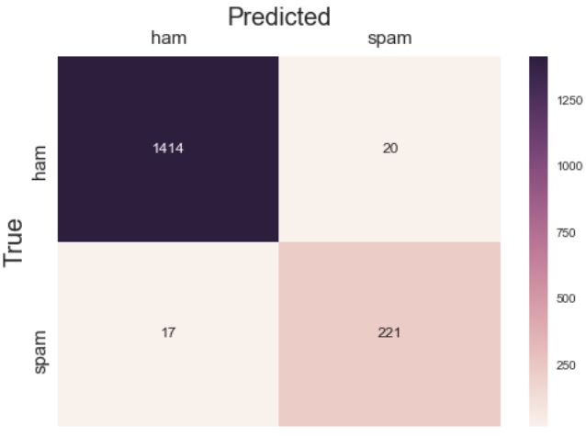

Fig. 4.9
5.3 CROSS VALIDATION

There are various methods for assessing a classifier's performance after training. The holdout method, which divides the dataset into two portions for training and testing, is one straightforward technique. The outcomes of this strategy, however, greatly depend on how the sample set is divided, which is a disadvantage. K-fold cross-validation is another way that lowers the holdout method's variability.

The dataset is split into k distinct, non-overlapping portions for k-fold cross-validation, and the model is trained on one part and tested on another. Each component serves as the test set once during this procedure' repetition k times. The outcomes of all k tests are averaged to assess performance. The mean of the findings from each individual test is employed to determine the recall and precision for a k-fold test.

The accuracy p and recall r for the k-folded test are specified as,
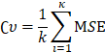

The mean of the precision and recall from each individual test is what is referred to as the k-fold test's precision and recall. Research has demonstrated that k=10 is sufficient, and the experiments in this thesis employed this approach.

6. RESULTS AND DISCUSSION

Predictive accuracy was developed as the most important evaluation criterion in order to have a thorough picture of the scenario. The following formula was used to determine this.

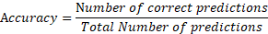

Correctly Classified Instances+ Incorrectly Classified Instances = Total Number of Instances .

Accuracy = (TrueNegative + TruePositive)/
(TruePositive + FalsePositive +
TrueNegative + TruePositive)

P.A. stands for prediction accuracy.
The sum of the cases that were correctly classified and those that were wrongly classified yields the total number of instances.

How well an algorithm anticipates the requested data is determined by its predictive accuracy. Three factors— accuracy of predictions, training time, and the error rate —were considered for evaluating the dataset’s performance.

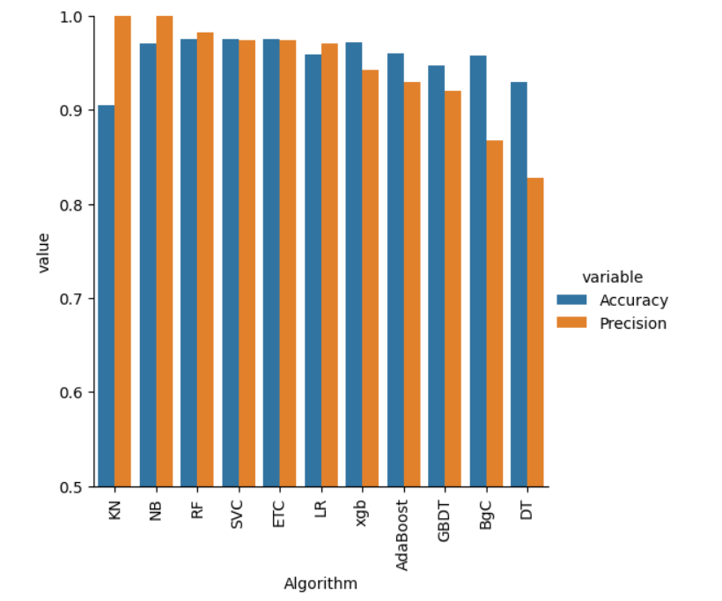

7. CONCLUSION AND FUTURE WORK

In this research, a common dataset is used to implement the thorough study of various classifiers. On the basis of the previously indicated evaluation criteria, the outcomes are compared. This study demonstrates that the performance of a classifier that is identical when carried out over an identical dataset using different software packages. The Nave Bayes classifier is a solid choice. The performance of some classifiers, such as Simple Logistic and Adaboost, is good. However, MLP is superior when compared to it. As a result, MLP makes a decision in every situation based on all comparisons and viewpoints.

ACKNOWLEDGMENT

The authors are appreciative of our department's and our organization's invaluable assistance.

REFERENCES
- C. Pu and S. Webb, “Observed trends in spam construction techniques: A case study of spam evolution”, Proceeding of 3rd Conference on E-Mail and Anti-Spam, 2006.
- M. Embrechts, B. Szymanski, K. Sternickel, T. Naenna, and
R. Bragaspathi,“Use of Machine Learning for Classification of Magnetocardiograms”, Proceedings of IEEE Conference on System, Man and Cybernetics, Washington DC, pp. 1400-05, 2003.
- Duncan Cook, Jacky Hartnett, Kevin Manderson and Joel Scanlan, “Catching Spam before it arrives: Domain Specific Dynamic Blacklists”, in ACSW Frontiers, Australian Computer Society, Vol. 54, pp. 193 –202,2006.
- Bekker S, “Spam to Cost U.S. Companies $10 Billion in 2003”, ENTNews, http://www.entmag.com/news/article.asp?EditorialsID=565 1>.
- D. Puniškis, R. Laurutis and R. Dirmeikis, “An Artificial Neural Nets for Spam e-mail Recognition”, Electronics and electrical engineering, Vol. 69, No. 5, pp. 73 – 76, 2006.
- Youn and Dennis McLeod, “A Comparative Study for Email Classification”, Proceedings of International Joint Conferences on Computer, Information, System Sciences and Engineering, 2006.
- Witten I. & Frank E., “Data Mining: Practical Machine Learning Tools and Techniques with Java Implementations”, Morgan Kaufmann Publishers, 2000.
- Upasana Pandey and S. Chakraverty “A Review of Text Classification Approaches for E-mail Management”.

